IIITD&M Kancheepuram

**Problem solving and programming**

**Date: 24 JAN 2021**

**Duration: 01 Hr. Total Marks: 20**

1. What is the output for the following program? Justify your answer properly

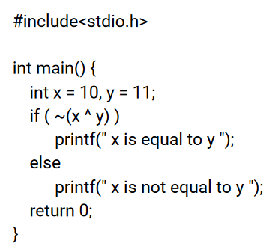

1. Write a ​Program to find the Maximum and minimum of two numbers without using any loop or condition.
2. Find the output of the below program and justify your answer

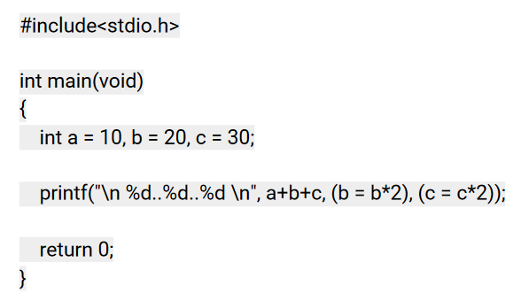

1. Suppose 9 bits are used to represent an unsigned integer. Answer the following:

a. What is the smallest integer?

b. What is the largest integer?

1. Suppose a compiler assigns 2 bytes to store an integer.

Perform the addition of 20 and -30 using

* + 1. 1s Complement Representation.
    2. 2s Complement Representation

1. Find the output of the below program

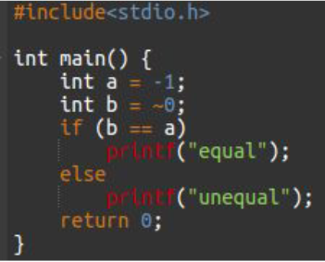

1. Perform binary subtraction using 2’s complement for the following. Check that it is correct by including the decimal equivalents. Include steps followed for each conversion. (2m)
   * + 1. 1011011 − 10010

B) 1110110 − 1010111

8. The smallest integer that can be represented by an 8-bit number in 2’s complement form is

1. The hexadecimal representation of 657 base 8 is
2. Convert the octal number 0.4051 into its equivalent decimal number.